Lab 6.2: Layout with css

Nội dung
6.1 Layout with style 2
6.2 Layout with DIV tag 2
6.3 Exercise 1: Modify 8.1 using DIV tag 3
6.4 Exercise 2: CSS Box Model 3

Layout with style
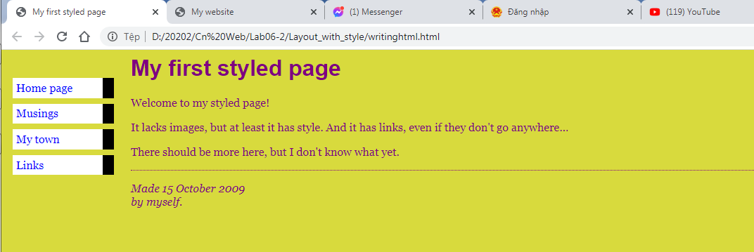

Layout with DIV tag
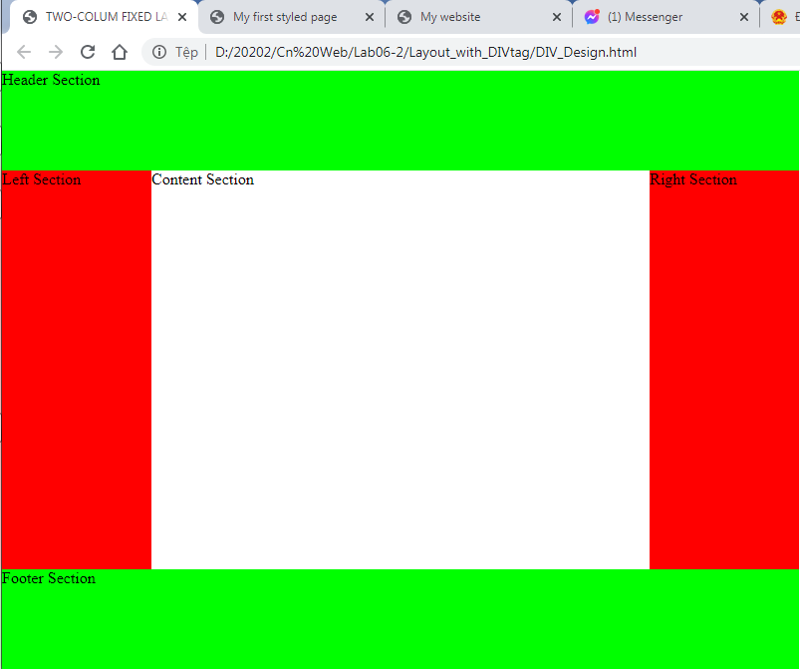
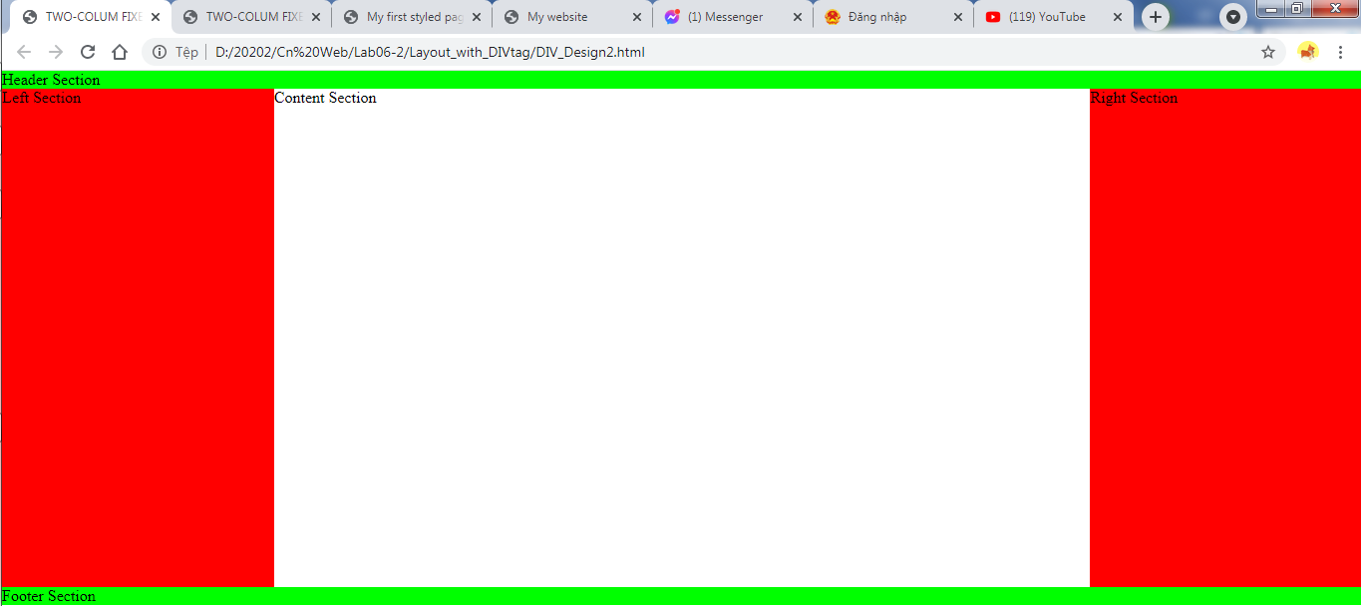

Exercise 1: Modify 8.1 using DIV tag
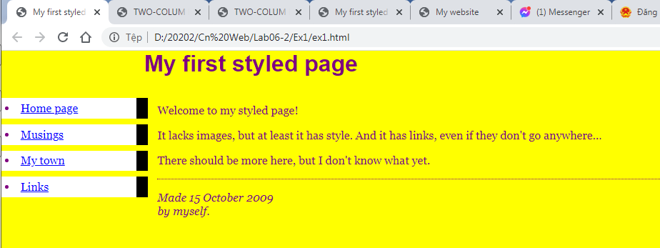

Exercise 2: CSS Box Model
